**SMART FASHION RECOMMENDER APPLICATION**

PREPARE EMPATHY MAP

TECHNICAL ARCHITECTURE:-

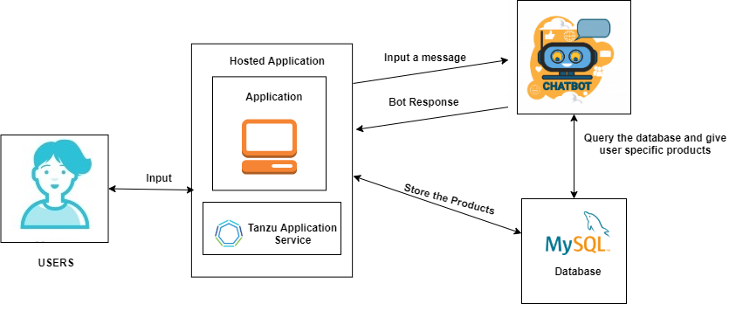

Fig-1: Evaluation Process

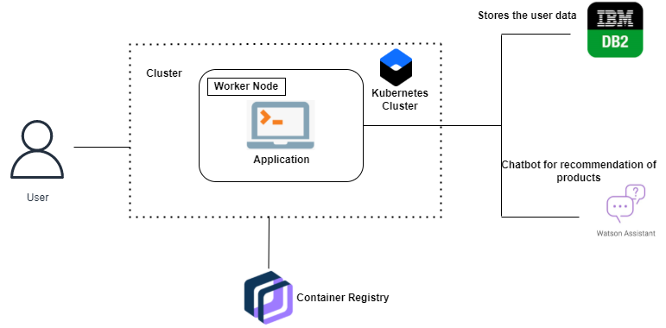

Fig 2: Architecture of Overall way of Processing Model